07.12.2023
Request for Proposals:

Discovery Reef Main Tank Chiller Replacement

The Columbus Zoo and Aquarium (CZA) is seeking proposals to provide a complete and fully operational replacement chiller system for the Discovery Reef Main Tank Chiller.

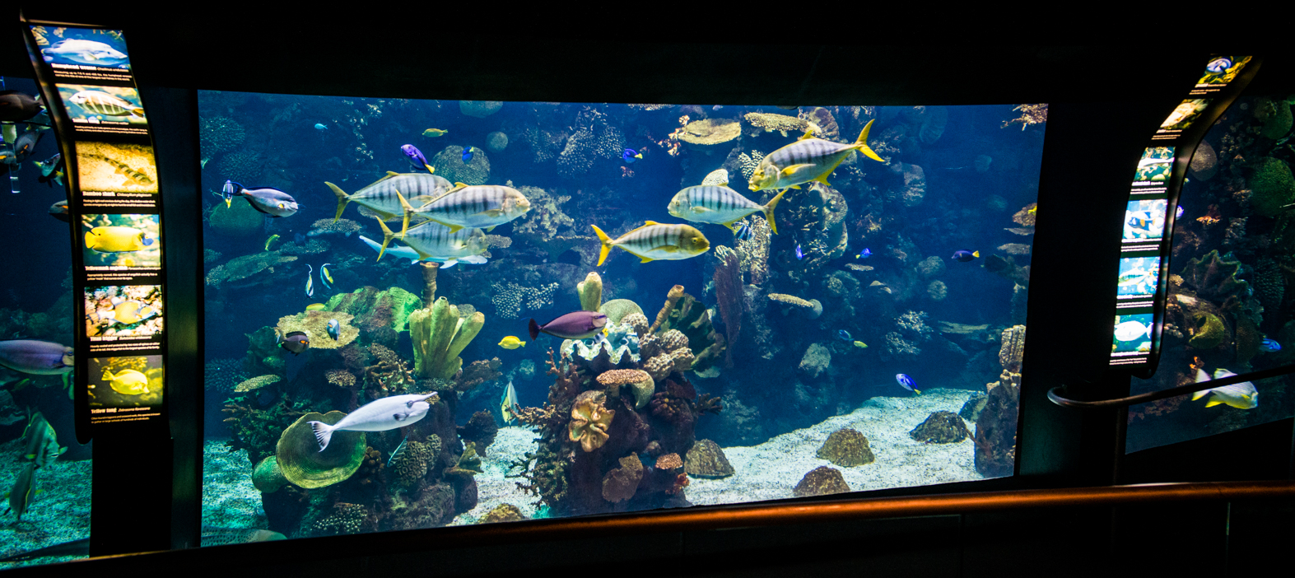

Table of Contents
Attached Exhibits 2
CZA Stakeholders & Project Management 2
Introduction 3
Project Background and Goal 3
Scope of Work 3
Proposed Project Schedule 4
Proposal Submission Format and Requirements 5
Proposal Selection Procedure, Terms, and Conditions 6
Bid Proposal Form 8
Commitment to Minority Business Participation Form 9

Attached Exhibits

The documents attached to this RFP as “Exhibits” should provide more definition.

- Exhibit A: Photos & Descriptions of Equipment
- Exhibit B: Blank Small Scope Construction Contract
- Exhibit C: Bid Bond Form
- Exhibit D: Performance and Payment Bond Form
- Exhibit E: Directions to Business Office
- Exhibit F: Existing System Drawings and Specifications
- Exhibit G: PLC System Specifications
- Exhibit H: Vendor Setup Form (New Vendors Only)
- Exhibit I: PLC Specifications and Photos

CZA Stakeholders & Project Management

Please include all CZA staff listed below in all correspondence regarding this project.
- Karen Schenk, Senior Director, Planning and Design (Karen.Schenk@ColumbusZoo.org)
- Joshua Casto, Project Manager, Facilities and Planning (Josh.Casto@ColumbusZoo.org)

Introduction

Our Mission: Empowering People. Saving Wildlife.

The Columbus Zoo and Aquarium Association (CZA) is a 501 (c) (3) not-for-profit organization that manages and operates a highly acclaimed zoo, a golf course, and an LLC waterpark on 612 adjacent acres of land on the northwestern outskirts of Columbus, Ohio.

The Columbus Zoological Park Association, Inc. was organized in 1930 as a not-for-profit corporation. The functions of the Association are to make the public more aware of conservation issues, education programs and recreational opportunities, to encourage civic involvement in the Zoo, to raise funds for the acquisition of animals and to plan Zoo improvements.

Project Background and Goal

There are several pieces of equipment and associated piping which controls the water temperature in the Discovery Reef Aquarium. This equipment and associated piping are beyond their expected lifecycle and need to be replaced with new, updated equipment.

Project Goal: New, updated equipment in the Discovery Reef chiller systems and old equipment removed and properly disposed.

Scope of Work

The successful contractor will be responsible for all Scope of Work as defined in the attached Contract, and as described in this RFP and other attachments, if applicable.

- Furnish all labor, materials, and equipment required to provide a turn-key solution for a fully operational replacement chiller system for the Discovery Reef.
  - Remove and properly dispose of old Chiller Barrels and associated piping. Replace with more efficient and updated materials without loss of functionality during installation.
  - Remove and properly dispose of the old compressor and associated piping. Replace with more efficient and updated materials without loss of functionality during installation.
  - Remove and properly dispose of old condenser. Replace with more efficient and updated materials without loss of functionality during installation.
  - Proposed power consumption methods cannot exceed current output; building is at capacity.
  - The chosen contractor will ensure all equipment and materials are on site prior to work beginning, including a temporary generator to ensure power connectivity during any disconnects.
- Author a proposed operational installation schedule which clarifies how the temporary and replacement systems will not interrupt ongoing life support systems while installation takes place. This plan to be reviewed and approved by CZA prior to procurement.
- Provide a proposed design for replacement of identified LSS equipment inside of the building.
- Provide an alternative design for replacement of identified LSS equipment outside of the building.
  - Owner to provide any future outside structure to protect any equipment placed outside of the building.
- All items of installation, if possible, should provide connectivity to the Discovery Reef’s PLC Control panel for monitoring of equipment.
  - All equipment will ensure amperage/power draw does not exceed existing equipment due to existing power limitations in the Discovery Reef building.
  - Selected contractor to provide software license for PLC software installation.
  - Selected contractor to be proficient in the Win-911 system, and, ensure newly installed equipment functions with Win-911 (SmartSights).
  - The selected contractor will be responsible for updating the FactoryTalk Server HMI & location HMI monitoring system, also including the HMI visual interface.
  - Chosen contractor to coordinate with CZA technology staff throughout software installation process, including at project close to ensure functionality.
- Provide a temporary chiller system for marine life that cannot be temporarily relocated during equipment removal and replacement.
  - Temporary system must be functional throughout the project.
  - System must have the ability to attach to a generator via an ATS or manual.
- Provide as-built drawings post-installation for CZA future reference in Tabloid (11x17) PDF form.

Proposed Project Schedule

CZA requests that each bidder provides a schedule reflecting an accurate portrayal for the anticipated work.

- RFP Advertised & Distributed: Wednesday, August 9, 2023
- Intent to Attend Pre-Bid: Monday, August 14th by 4pm
- Pre-Bid Meeting: Wednesday, August 16, 2023, 9am ET
- Questions Deadline: Wednesday, August 23, 2023, 4pm ET
- Bid Deadline: Wednesday, August 30, 2023, 12pm ET
- Selection/NOI: Friday, September 8, 2023
- Signatures: Friday, September 15, 2023
- Design Due: Friday, October 6, 2023
- Installation: (On or Before) Thursday, February 29, 2024

*Private meetings will not be accommodated. The Pre-Bid meeting on Wednesday, August 16, 2023, 9am ET. Please meet in front of the business office (See Exhibit E.). CZA requires notice with list of names and associated company be provided to Josh.Casto@columbuszoo.org and Karen.Schenk@columbuszoo.org at least two business days prior (Monday, August 14th by 4pm ET) in order to grant access.

Proposal Submission Format and Requirements

The following criteria are applicable and should be considered for the proposal:

- Equal employment opportunity
- Project is not prevailing wage.
- CZA has a goal of 10% project spend for MBE, including yourself and/or any subcontracted companies.
- Drug Free Safety Policy Requirements
- This project is tax exempt.
- A bid bond, performance and payment bond are required.

Please include the following information in your submission:

- Corporate Information
  - Provide company name, officers as applicable and their contact information.
  - Provide a brief overview of the company’s history, including services provided.
  - State limits and deductible of professional liability coverage.

- Relevant Experience
  - Summarize the identified individuals’ general experience in projects of similar scope, budget and complexity.

- Strategic Approach
  - Provide a statement of your company’s understanding of the proposed Scope of Work and how well your firm might be able to respond to that Scope of Work, and the proposed project schedule.
  - Provide a brief description of your firm’s proposed process for completing the Scope of Work, including how you envision your interaction with and contractual responsibility to the CZA staff.

- Construction Fee Philosophy
  - Provide your proposed cost for the materials and work for the construction project.
  - Please provide a detailed description or matrix of what services you propose to provide for this project.
  - Identify any other pertinent information that would relate to your firm’s philosophy regarding costs, ownership of errors and omissions, partnership opportunities, etc.

- Minority Organizations
  - Identify any means in which you intend to try to utilize minority organizations in order to help the Zoo achieve the 10 % goal for this project. This includes the names of any intended subcontractors you wish to use, including electric.

Proposal Selection Procedure, Terms, and Conditions

- Questions concerning the Proposal Submission, or the Scope of Work must be directed electronically to Karen Schenk, PLA, LEED GA, Sr. Director of Planning + Design, Planning and Facilities Department at Karen.Schenk@columbuszoo.org and Josh Casto, Planning and Facilities Project Manager at Josh.Casto@columbuszoo.org .Responses to any questions will be sent in the form of an addendum.
- An electronic copy of the proposal shall be emailed to: Karen.schenk@columbuszoo.org and Josh.Casto@columbuszoo.org.
- Proposals must be received electronically no later than Wednesday, August 30, 2023, 12pm ET. Proposals received after this time will not be considered. CZA will provide a confirmation of receipt; if you do not receive confirmation, please reach out to Josh Casto at 1-614-724-3325.
- Questions will not be entertained after Wednesday, August 23, 2023, 4pm ET
- All responses received by the deadline will be evaluated by an internal selection committee, which may lead directly to the selection of a particular firm for an interview.
- The chosen firm will receive a “Letter of Intent.” Candidates not selected for the project will be informed by the CZA in a timely manner.
- All costs of developing these proposals and any subsequent expenses relating to an interview process or to contract negotiations are entirely the responsibility of the Proposer and may not be charged to the CZA.
- It is the policy of the CZA to solicit proposals with a bona fide intention to award a contract. This policy notwithstanding:
- This Request for Proposal is not subject to the competitive bidding process.
- Any contract entered as a result of any proposal submittal will not necessarily be based on the concept of lowest apparent bidder.
- The CZA reserves the right to accept or reject any or all RFP’s that may be submitted or to procure any service by any other means.
- The CZA reserves the right at any time to modify the selection process or the scope of the project or the required responses.
- Soliciting proposals does not commit the CZA to accept any terms of any proposal. Final terms of any agreements are subject to the approval of the CZA.
- Submission of a response to this RFP constitutes express acceptance by the Proposer of all provisions of this Request for Proposal.
- If you and or your company has never worked for the Columbus Zoo & Aquarium, please fill out “Exhibit H: New Vendor Setup Form” for our records.

Acknowledgement of Addendum
Bidders must submit this acknowledgement form with their response. One acknowledgement form per response, listing all addenda, is appropriate.

Addendum No.: ___
Addendum No.: ___
Addendum No.: ___
Addendum No.: ___
Addendum No.: ___
Addendum No.: ___
Addendum No.: ___
Addendum No.: ___
Addendum No.: ___
Addendum No.: ___
Addendum No.: ___
Addendum No.: ___

Company Name: ____________________________________________
Representative’s Name: ______________________________________
Signature: _________________________________________________
Date: _____________________________________________________

Bid Proposal Form

In addition to filling out this bid form, please attach an additional sheet breaking out your bid by labor and materials division. Please use the standard CSI Master format.
Bidder will complete all work associated with the Design Build project in accordance with the RFP and Attached Exhibits.
Preconstruction Services – Includes all survey, engineering, design and permitting costs and is a Not-To-Exceed Cost of $_________________.
Construction Fee -________% of the total cost of the work.
General Liability Insurance - ______% of the project costs.
General Conditions - $_____________. This cost is based on a _________month schedule with a total project cost (Survey, Engineering, Design, permitting and construction) of not more than $1.1M. A copy of this breakdown is attached.
General Requirements - $_________ - This cost is based on a ________ month scheduled a project cost of $_____________. A copy of this breakdown is attached.
Contingency – Recommended Contingency Amounts to be Carried Throughout the Project:
Schematic Design Budget: _____%
Design Development Budget: _____%

Commitment to Minority Business Participation Form

Use “✓” or “X” to mark option included in bid.
If marking Option B, please also show the percentage of proposed participation.
______ Option A
Bidder commits to meet or exceed the advertised MBE participation goal of the contract award amount, calculated as a portion of the base bid plus all accepted alternates, by using certified MBE business enterprise(s) or other group as described in the RFP.
Bidder agrees that if selected for consideration of the contract, it shall provide (if not provided with the Bidder’s base bid) to the CZA, within 3 business days after receiving notice from CZA, MBE affidavit form for each certified business enterprises proposed for use by the bidder if awarded the contract for this project.
______ Option B
Bidder does not meet the advertised MBE or other group as described in the RFP Participation Goal percentage, but if awarded the contract for this project, commits to provide _____ percent of the contract award amount, calculated as a portion of the base bid plus all accepted alternates, by using certified MBE business enterprises or other group as described in the RFP.
Bidder acknowledges it understands the requirement for it to provide and agrees to provide to the CZA, if selected for consideration of the contract, within 3 business days after notice from CZA, a “Demonstration of Good Faith” form describing its efforts undertaken prior to submitting its bid to meet the advertised MBE participation goal percentage for the contract for this project.
______ Option C
Bidder declares that the bidder is certified MBE business enterprise or other group as described in the RFP and that if awarded this contract, the MBE participation percentage will be 100 percent of the Contract award amount.

